# Motor Modeling Hardware

The reason for this guide is to provide the user with the information and drawings required to construct the testing hardware required to model the quadcopter motor performance. Low cost and easily obtained components were chosen where possible to make assembling the testing system easy and affordable. Numerous modifications are possible that might make the testing system given here more appropriate for your purposes, so this information is intended to provide a reference for you to elaborate on as you see fit. Once the reader understands the intended functionality of these designs, it is recommended that they modify them (particularly in terms of dimensions) to suit their needs considering tools and materials they have available, quadcopter size, etc.

Table of Contents

Motor Modeling Hardware 1

Torque Measurement: 3

Theory of Operation: 3

Materials Needed: 3

Discussion 6

Thrust Measurement: 7

Theory of operation: 7

Materials Needed: 8

Discussion 10

Phototransistor Assembly 12

Quadcopter control system verification test rig (test cage) 14

References 19

Appendix: Combination torque and thrust rig difficulties 20

## Torque Measurement:

### Theory of Operation:

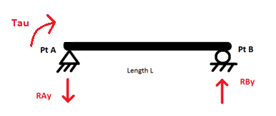

τ

Figure 1 Force diagram for torque stand

Figure 1 and the equation below shows that the torque being generated by the mounted motor can be found by reading the force on the scale ($RB_{y})$ and multiplying it by the distance from the center of the motor to the vertical threaded rod ($L$).

$\sum{M_{A} }=0= -τ+\left(RBy∙L\right)$ (Figure 1 moment equation about point A)

$Torque of Motor=τ=RBy∙L$ Eq. 1

### Materials Needed:

|  |  |  |  |  |  |
| --- | --- | --- | --- | --- | --- |
| *ID* | *Description* | *Quantity* | *ID* | *Description* | *Quantity* |
| **1** | 7" x 1.25" x 1.25" Wood, square dowel | 1 | **-** | 1/8" Machine Screw Nuts | 14 |
| **2** | 5" x 0.75" x 2.125" Wood, Flat Piece | 1 | **6** | 1.25" x 1" x 1" Aluminum Block * | 1 |
| **3** | 6" x 2.25" x 0.75" Wood, Flat Piece | 1 | **-** | 1/8" x 0.75" Wood Screws | 4 |
| **4** | 2.5" x 0.25" x 1.5" Plexiglass, Flat* | 1 | **7** | 1/2" Long 6-32 Thumb Screw | 1 |
| **5** | 5/16" x 3" Bolt | 1 | **8** | 1/8" x 8.5" Threaded Rod | 1 |
| **6** | 5/16" Nuts | 2 | **9** | 0.25" x 11" Aluminum Rod bent into 90° * (See Figure) | 1 |
| **-** | 1/8" x 2"Machine Screws | 4 | **10** | Phototransistor * | 1 |
| **-** | Generic skateboard bearings (5/16” I.D.) | 2 | **-** | Digital Scale * | 1 |
| **-** | Arduino Uno w/ Associated Wiring * | 1 | **-** | Clamp (C-clamp or similar) * | 1 |

* Indicates component that may benefit from material substitution at user’s discretion

* Indicates component that may be used for both the torque and thrust rigs

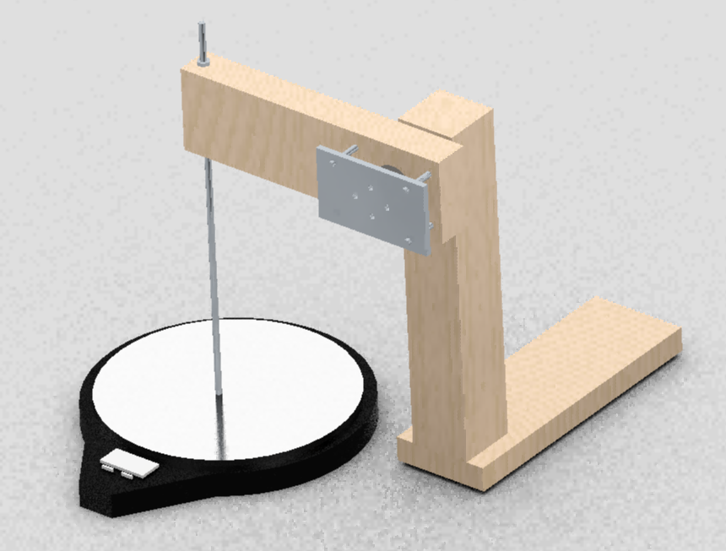

Figure 2. Torque Measurement Rig (shown without motor or phototransistor)

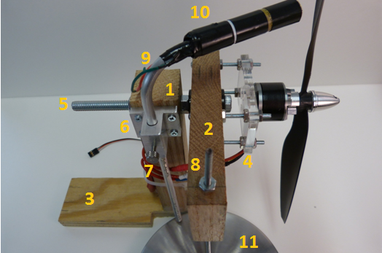

Figure 3. Labeled photo of torque rig as built

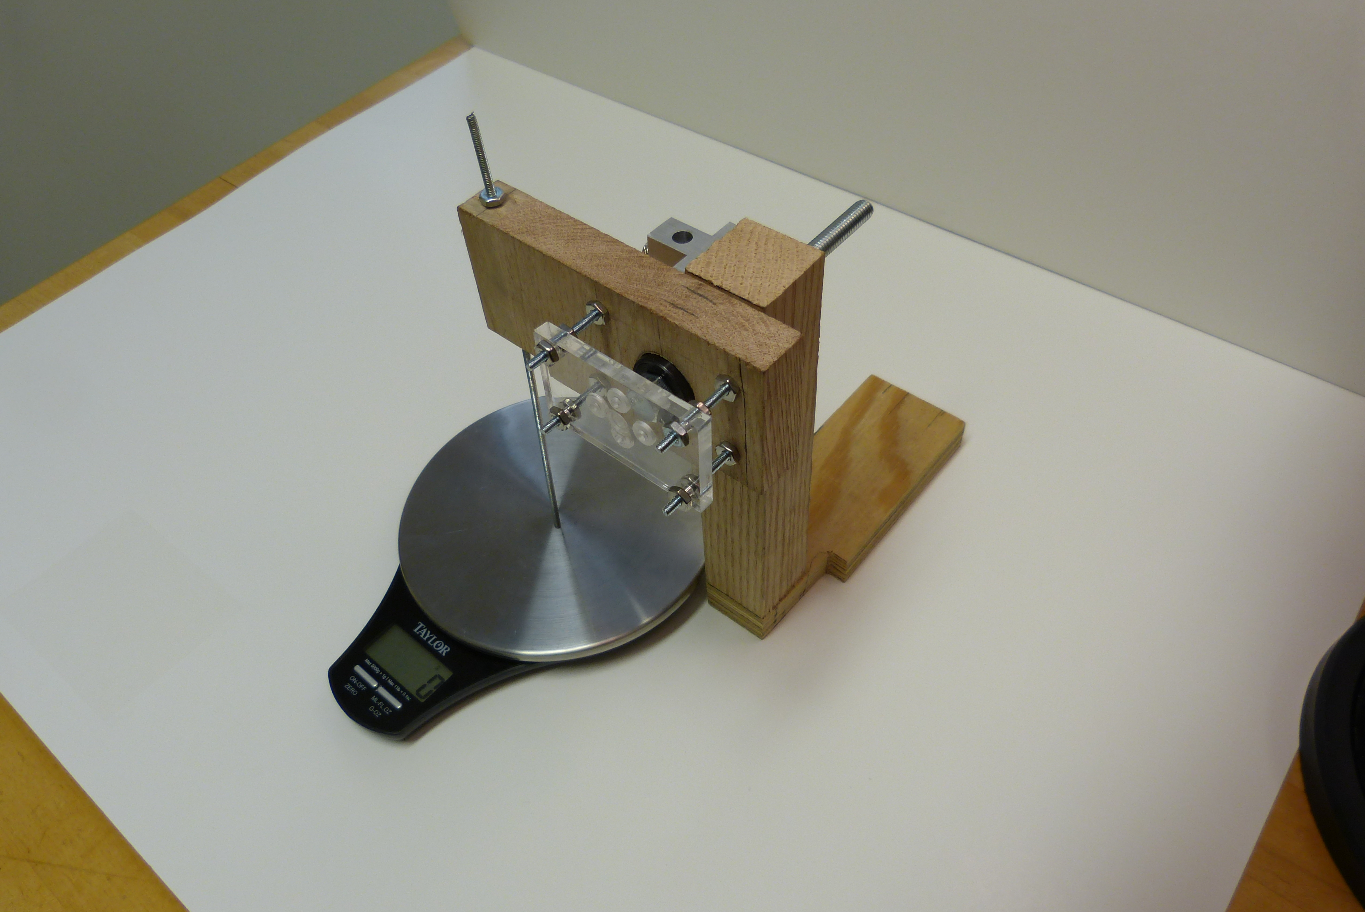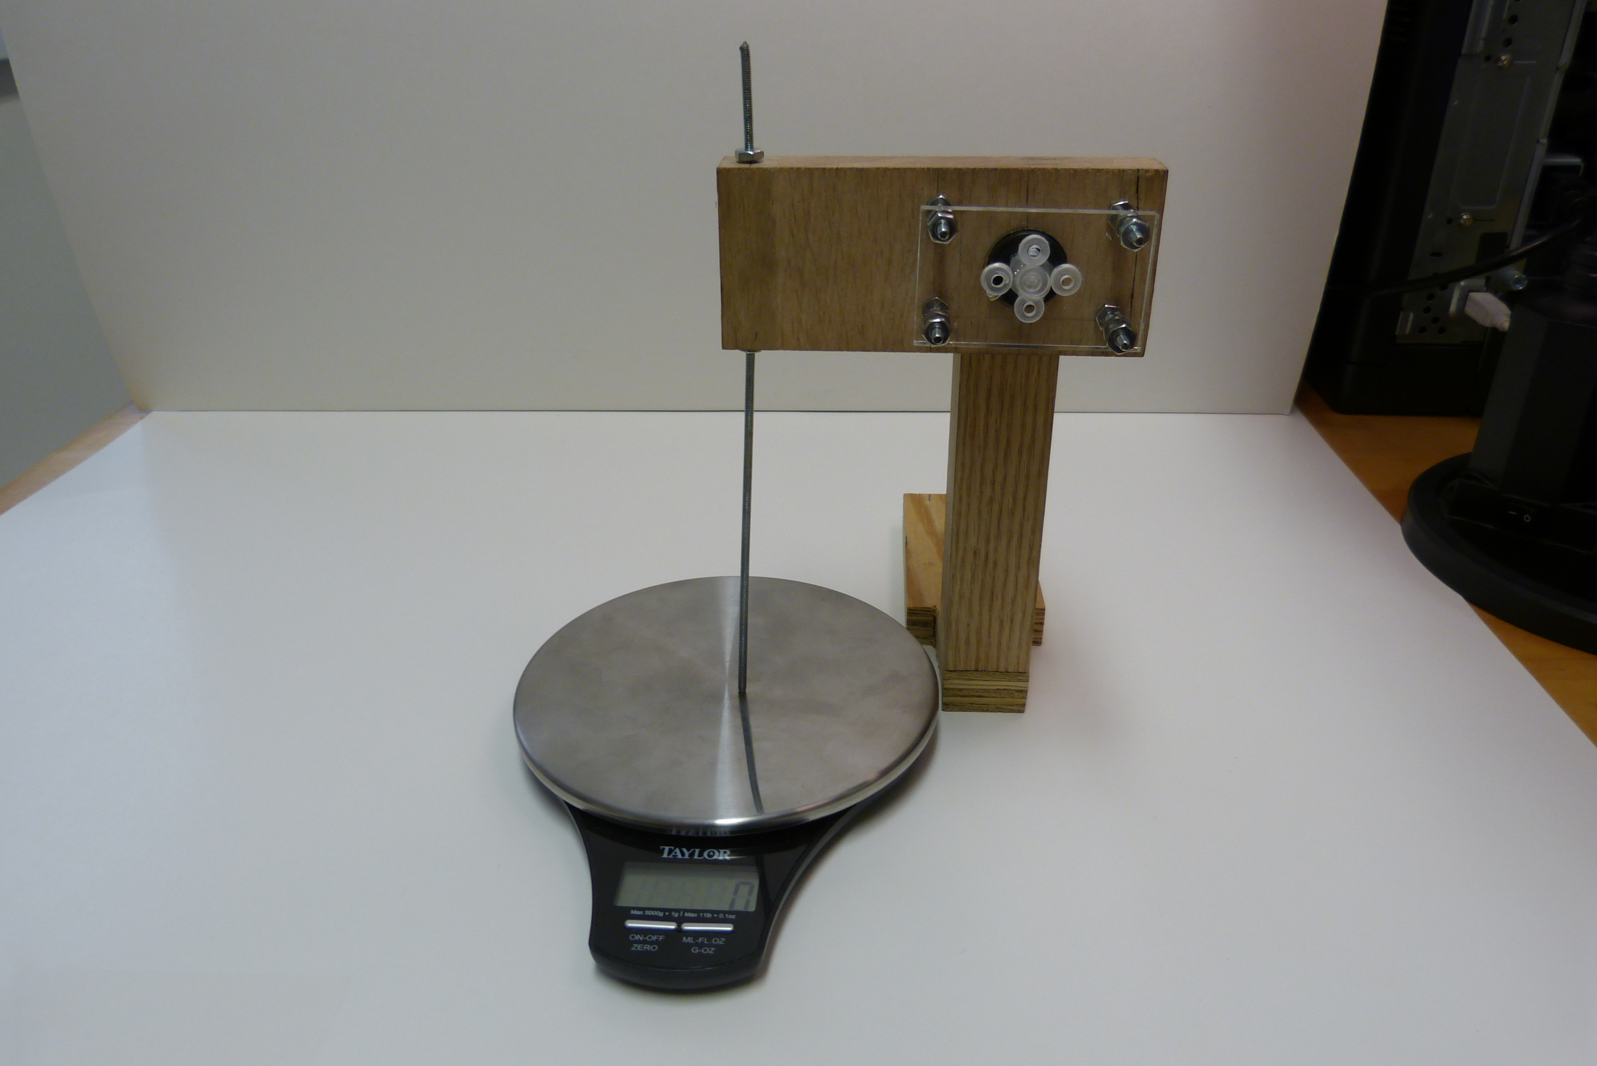

Figure 4. Torque stand as built (Motor and phototransistor not shown)

### Discussion

Construction of the torque test stand can begin by attaching the square dowel (**1**) to the center of the base (***3***) so that it extends vertically from one end of the base (Figure 2). *NOTE: Small notches can be cut into the base (****3****) next to the vertical piece so that the threaded rod contacts the center of the scale (this can be done after a scale is selected if necessary)*. At the top of the 7" square dowel, a hole for the 5/16" bolt needs to be drilled. A matching hole is also drilled into the 5" flat piece (**2**), but on this piece, you will need to drill larger diameter reliefs for the bearings so they can slide into them securely. It is important that the bearings have good alignment on either side of the piece and sit securely in their recess.

On the 0.75" side (edge) of the 5" flat (**2**), a 1/8" hole is drilled near the end so that the 1/8" threaded rod (**8**) can be passed through it. Around the 5/16” bolt hole, four 1/8" holes are drilled to match with holes in the plexiglass flat piece. The 5" flat (**4**) piece to the plexiglass will be attached using the 1/8" machine screws and nuts to hold it in place away from contact with the 5/16" bolt head (the nuts are used to offset this piece (**4**) from the base, see Figure 2). In the center of the Plexiglass, **directly aligned with where the 5/16” bolt axis falls,** countersunk holes with a pattern matching the motor mounting holes should be drilled. Plexiglas proved reasonably convenient for us, though a strong wood or even metal material could be substituted for this purpose. The phototransistor (see section “Phototransistor Assembly” below) can be secured to the top of the ¼” 90° bend aluminum rod with hot glue after it has been connected to permanent leads. A bit of tape and rolled cardboard paper can be use to make a “blinder” for the phototransistor that can be adjusted fore or aft to reduce ambient lighting (this was found to dramatically improve measurement results). The rod can be placed inside the phototransistor holder with the machine screw. When operating the stand, it is typically placed near the edge of a table so that a clamp can be applied to the 6" flat base to secure it. Alternatively a heavier/sturdier base can be fabricated if using some type of C-clamp or “Quick Grip” clamp is undesirable.

## Thrust Measurement:

The thrust stand concept was partially inspired by a web log post on [8], though we feel our design provides several improvements over similar examples we have encountered in our research.

### Theory of operation:

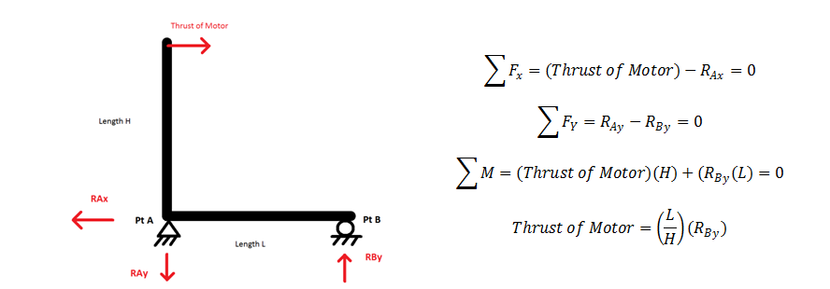

Figure 5. Force diagram for Thrust Rig

Figure 5 and the equation below show that the torque being generated by the mounted motor can be found by reading the force on the scale ($RB_{y})$ and multiplying it by the length of the scale arm (distance between A and B: “L”) divided by the distance from the center of the motor to the pin at A (“ $H$”).

$∑M_{A}=0=-\left(Thrust of Motor\right)∙H+RB_{y}∙L$ (Figure 5 moment equation about Pt. A)

$Thust of Motor=\left(\frac{L}{H}\right)∙RB_{y}$ Eq.2

From a design perspective, this can be a useful relation. For convenience, we might try to design for $\frac{L}{H}$ to equal 1. However, we might also choose to make $\frac{L}{H}$ small in order to increase the force measured on the scale for a given thrust (potentially improving the resolution of our measurement system depending on the scale used). We chose to design for an approximate $\frac{L}{H}$ of one (i.e. $L=H)$, and once the quadcopter arm was mounted in the test stand we measured each distance for use in our data analysis.

### Materials Needed:

|  |  |  |  |  |  |
| --- | --- | --- | --- | --- | --- |
| *ID* | *Description* | *Quantity* | *ID* | *Description* | *Quantity* |
| **1** | 1' x 1.25" x 1.25" Wood, square dowel | 1 | **6** | 5" x 0.75" x 3.5" Wood, flat | 1 |
| **2** | 5.5" x 1.25" x 1.25" Wood, square dowel | 2 | **7** | 5" x 0.75" x 4" Wood, flat | 1 |
| **3** | 5" x 0.75" x 2" Wood Flat | 1 | **-** | 1/4" x 3" Bolt | 2 |
| **-** | 1/4" Wing Nuts | 2 | **-** | 1/4" Washers | 4 |
| **-** | 3/4" Wood Screws | 4 | **-** | Flat 90° Angle Bracket w/ Screws | 2 |
| **4** | 3" Hinge w/ Screws | 1 | **-** | 1/4" x 2" Bolt | 1 |
| **-** | 1/4" Nut | 2 | **8** | Clamp * | 1 |
| **-** | Arduino Uno w/ Associated Wiring * | 1 | **-** | 1.25" x 1" x 1" Aluminum Block * | 1 |
| **-** | 1/2" Long 6-32 Thumb Screw | 1 | **-** | 1/8" x 0.75" Wood Screws | 1 |
| **5** | 0.25" x 11" Aluminum Rod * | 1 | **9** | Photodiode [9] * | 1 |
| **-** | - | - | **10** | Digital Scale [10] * | 1 |

* Indicates component that may benefit from material substitution at user’s discretion

* Indicates component that may be used for both the torque and thrust rigs

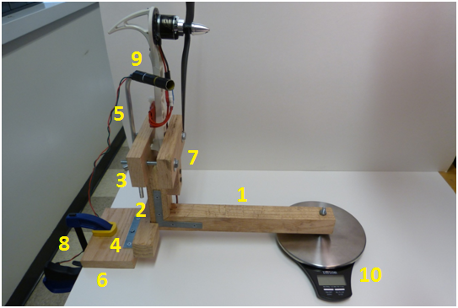

Figure 6. Labeled photo of thrust stand as built

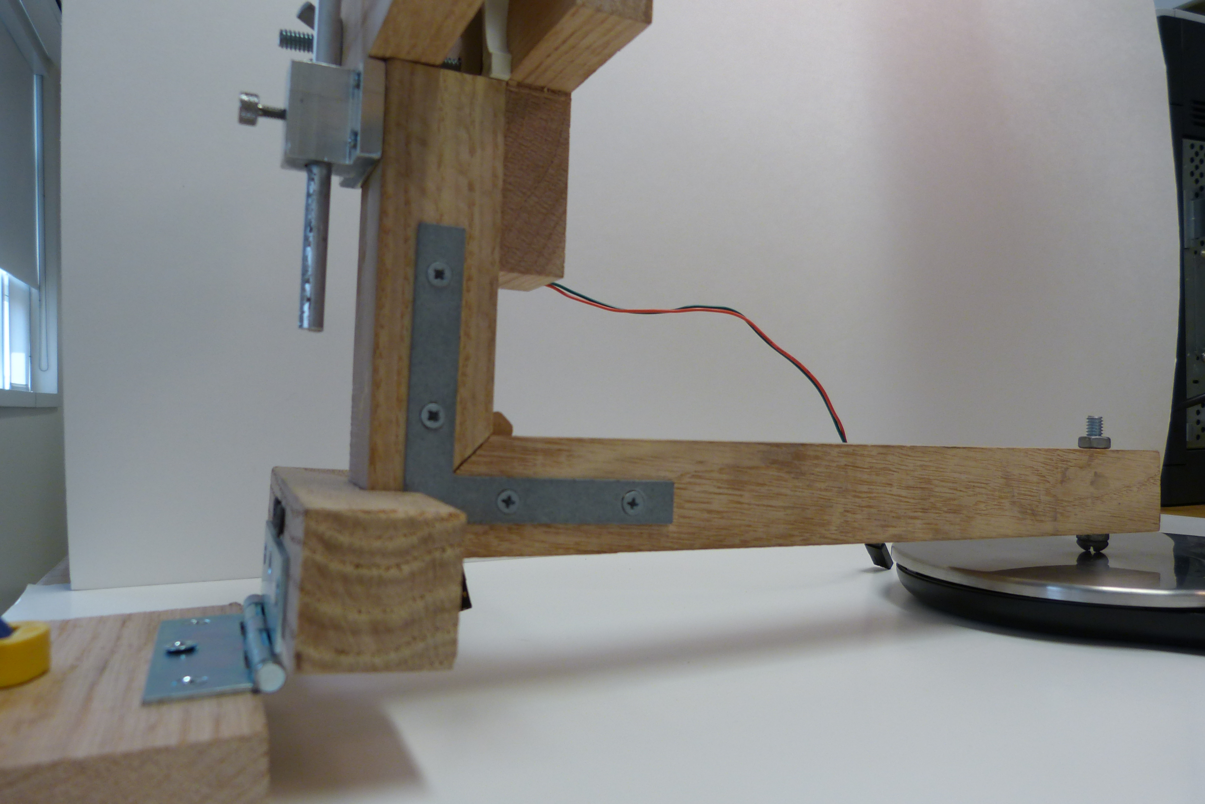

Figure 7. Side view of thrust rig as built

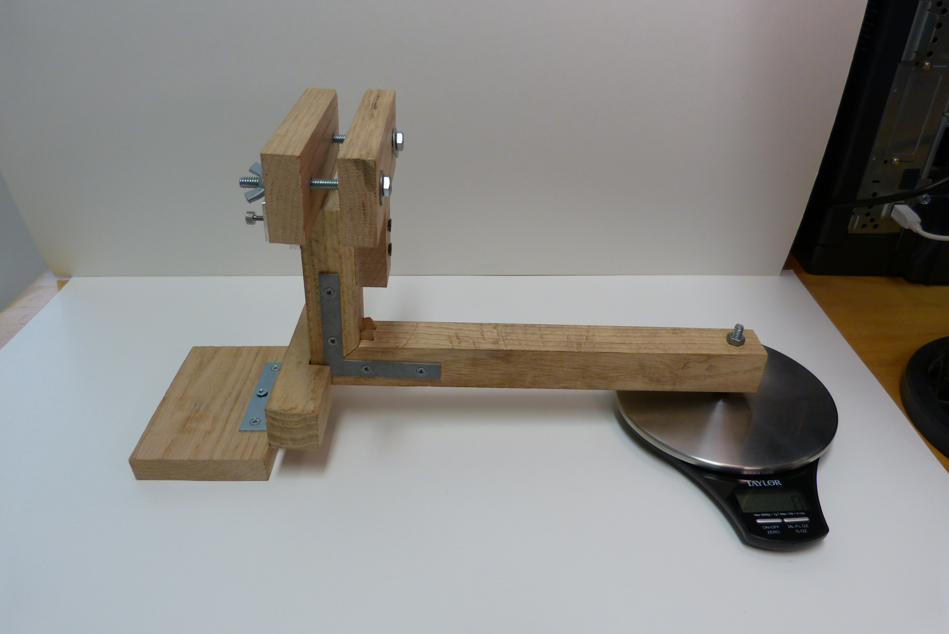

Figure 8. Side view of thrust rig as built

### Discussion

Thrust rig construction can begin by cutting a 0.5" x 1.5" notch into one of the 5.5" wood square dowels (2). This dowel is then connected to the 5" x 3.5" wood flat (6) with the hinge which will serve as the base of the stand. Next, the "L section can be made by cutting 45° angles into the ends of the 1' (1) and the second 5" wood square dowels (2), then securing the right angle they form with the right-angle brackets on both sides. At the end of the 1' dowel (1) there should be a 1/4" hole drilled through the center and the 1/4" x 2" bolt placed through it, using the corresponding nut, which will serve as a height adjustment to make good contact with the scale while keeping the horizontal piece (1) level with the table.

The newly formed "L" section is then placed inside the previous notch with two of the 3/4" wood screws. The next step is to cut a cross shape out of the 5" x 0.75" x 4" (6) wood flat; this will act as the stationary portion of the quadcopter arm clamp. This cross is screwed into the front of the vertical arm of the "L" section with two 3/4" wood screws so that the top part of the cross is sitting level with the flat top of the vertical arm. The 5" x 0.75" x 2" wood flat (3) is coupled to the top of the cross using the two 1/4" x 3" bolts, washers, and wing nuts. Loosening the wing nuts will allow this back wood flat to move away and create a space that the quadcopter arm can fit into, and then be retightened to act as a clamp. *The reasoning for attaching the entire arm of the vehicle, rather than removing the motor and attaching it directly to the test rig in some fashion, is that using this arrangement should produce airflow (and aerodynamic drag) very similar to what is obtained when the quadcopter is in flight*. The aluminum block (or other material) is machined into a 1/4" phototransistor rod holder that uses the thumbscrew and is mounted to the back of the "L" section arm with the four 1/8" x 0.75" wood screws (see section “Phototransistor Assembly” below). We were pleased with our thumbscrew photogate height adjustment block, but it might be overkill for your application. Consider designing a simpler arrangement if time is an issue or tools are not available. Finally, after the photodiode is placed at the top of the 0.25" x 11" rod, the rod is slid into the small holder and adjusted for operation. Both the thrust and torque test stands use the same Arduino circuitry setup, which is detailed in the Motor Test System documentation.

## Phototransistor Assembly

For reference, two pictures and a brief description is given here of the phototransistor probe assembly.

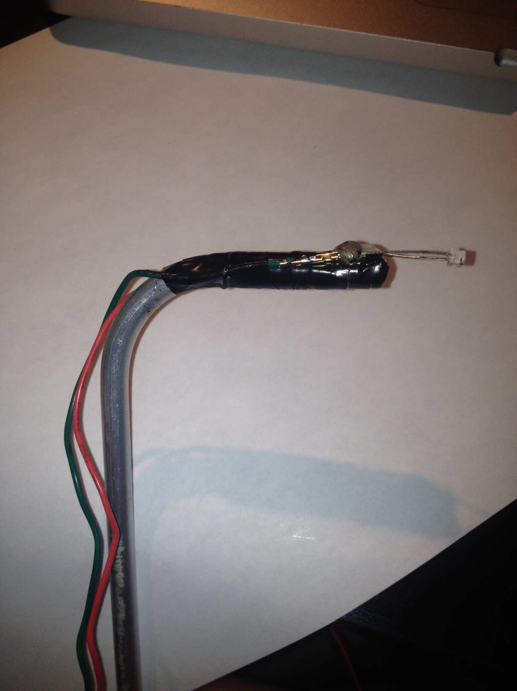

Figure 9. Phototransistor attached to 90° aluminum rod without cover

Electrical tape has been used to cover the aluminum rod to prevent a short. The phototransistor was connected to servo type wire connections at the end of short leads for convenience. The phototransistor was hot glued to the end of the probe as seen in Figure 9. An adjustable sleeve was fashioned using stiff cardboard paper and tape to cover the end of the probe and allow ambient light to be blocked (see Figure 10).

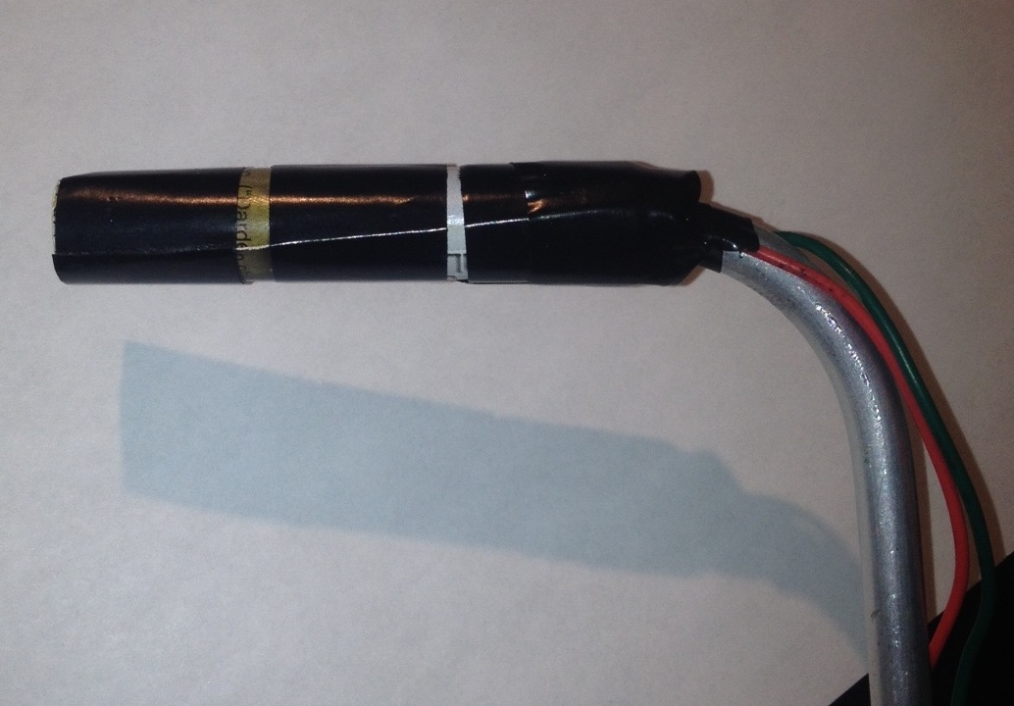 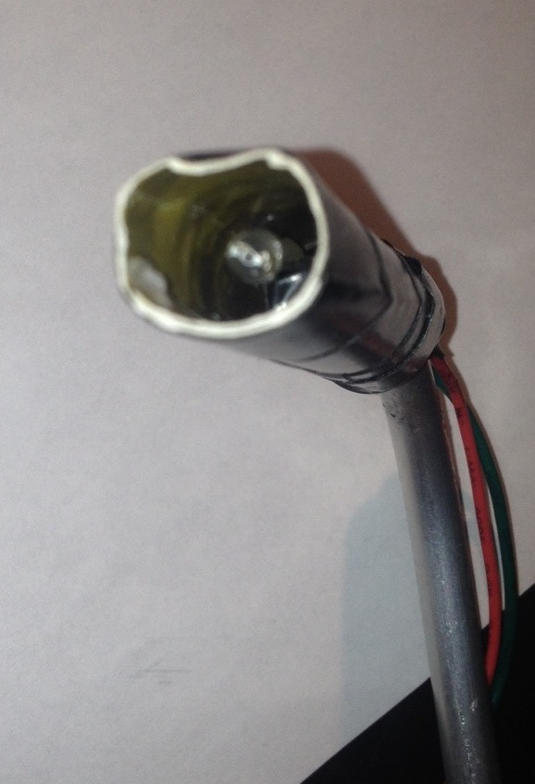

Figure 10. Phototransistor assembly with probe cover in place

## Quadcopter control system verification test rig (test cage)

Existing designs for quadcopter test stands vary substantially in design and function, but all seem to leave something to be desired. We chose to try to create a design with near neutral stability, and that would allow simultaneous pitch, roll, and yaw, control system testing. We also desired that attitude control system performance in the test rig should not be substantially different than what could be expected in flight. While reading through a number of research papers looking for ideas, a thesis by Dr. Paul Pounds [1] contained a section with discussion of real-world testing and shows several pictures of a test stand he used. Unfortunately, there is no in-depth description that could be used as a firm starting design. However, the photographs provided a conceptual starting point for us, which was very helpful and led us to our own design.

The test stand starts with a simple, square wood frame that has two countersunk through holes on the top and bottom beams. Inside these holes are a total of four skateboard bearings, one on each side of the wood, that then have an all-thread rod passed through them to facilitate unrestricted yaw movement. The ends of the rods attach to an aluminum rectangular frame that can be “rotated” (due to vehicle roll) into a rhombus shape in order to provide about ±20° of roll/pitch with the quadcopter inside. Coming in from the sides of the metal internal frame is a clamp assembly that holds the quadcopter's arms and rotates on two more pairs of bearings. The idea of the clamp was to allow multiple quadcopters to be used within the rig, though this functionality was never tested and in our opinion was perhaps not worth the added complexity.

Finally, the entire wood frame had to be lifted up away from the ground in order to avoid ground effect, so a stand was improvised utilizing a commercial sawhorse with slight modifications. In order to prevent damaging the vehicle, two angle restraints were added to the design; the u-shaped top block limits the aluminum frames roll movement and the bottom slotted plate and bolts limits pitch movement. The top block works by physically pressing against the top U-channel at the desired limits and the bottom restraint operates by limiting the amount of movement of the oversized wooden dowel between two upright bolts that can be adjusted closer or further away from the center, allowing variable restraint adjustment.

Clearly, this design is somewhat crude. We lacked adequate time to iterate through improvements to this design. However, a few words of advice will be offered for anyone trying to make a similar testing restraint system:

* Don’t use such long all-thread rods. The length makes them a bit too flexible. Shorten them a bit or find a stiffer alternative.
* Don’t pass the all-thread rod through the directly through the bearings, use a shaft with a better fit to the I.D. of the bearings (as they do on an actual skateboard). This will have a substantial affect on friction and produce more consistent operation.
* Provide something more secure than wood reliefs to hold the yaw bearings in alignment. We recommend machining (…accurately) a part for this purpose. Misaligned of these bearings has a profound affect on the friction along this axis. Fairly small alignment changes had a strong effect on our systems performance, which was a nuisance.
* At the four corners, and top and bottom mounts of the aluminum frame, there are “pin” joints. Care in designing these is recommended, as our design had more friction then desired since our “pins” were actually threaded screws (I know, I know). A design utilizing small bearings and/or smooth shafts might be effective.
* The top u-channel attitude restraint worked very well and was simple. The bottom was not as effective (though it still worked acceptably). A redesign using horizontal rollers on the restraint bolts could perhaps eliminate the need for the large wooden dowel and reduce roll friction when operating near the pitch limits.
* Mass moment of inertia was a constant consideration in our design process and we tried to use lightweight materials, and place heavy items as close as possible to the rotational axes of the vehicle and near to the center of mass whenever possible. This was because our interest was in replicating “flight dynamics” as much as possible in our stability control system testing.

Somewhat surprisingly, given our several “first try” design missteps, our results with this resting rig were fairly satisfactory. Though we didn’t have instrumentation available to incorporate into the rig, we feel that the test rig adequately allowed us to test the performance of our quadcopter control system. The test rig seemed to have rotational dynamics (particularly about the pitch axis, which uses the inner rods and bearings) that were comparable to simulation results and appeared to be very low friction, such that even a small mass imbalance caused the vehicle to rotate freely and react smoothly. For these reasons, we feel this design has substantial potential, but needs additional refinement before it can be considered a finished design.

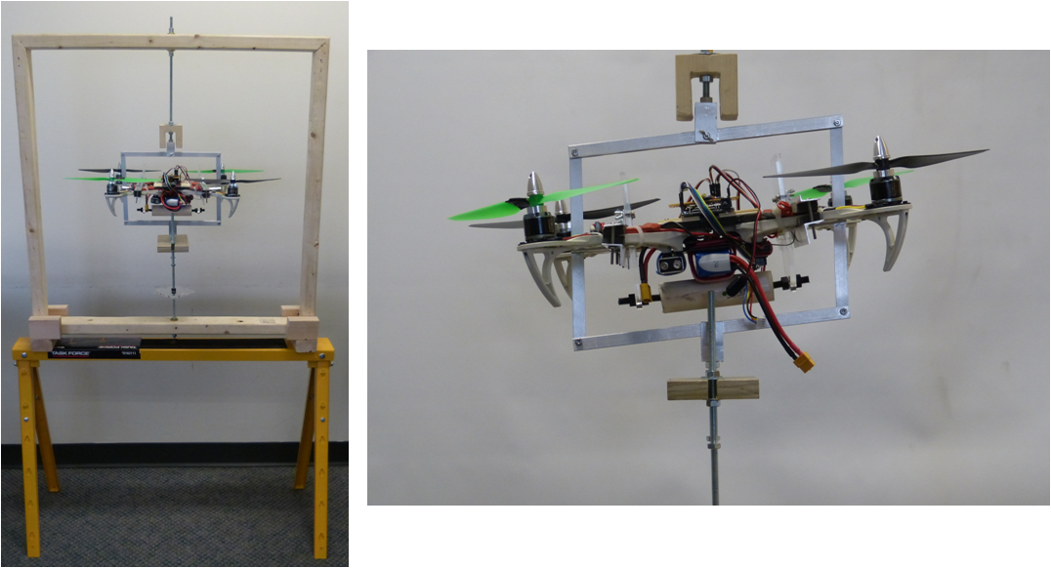

Figure 11. Test cage front views

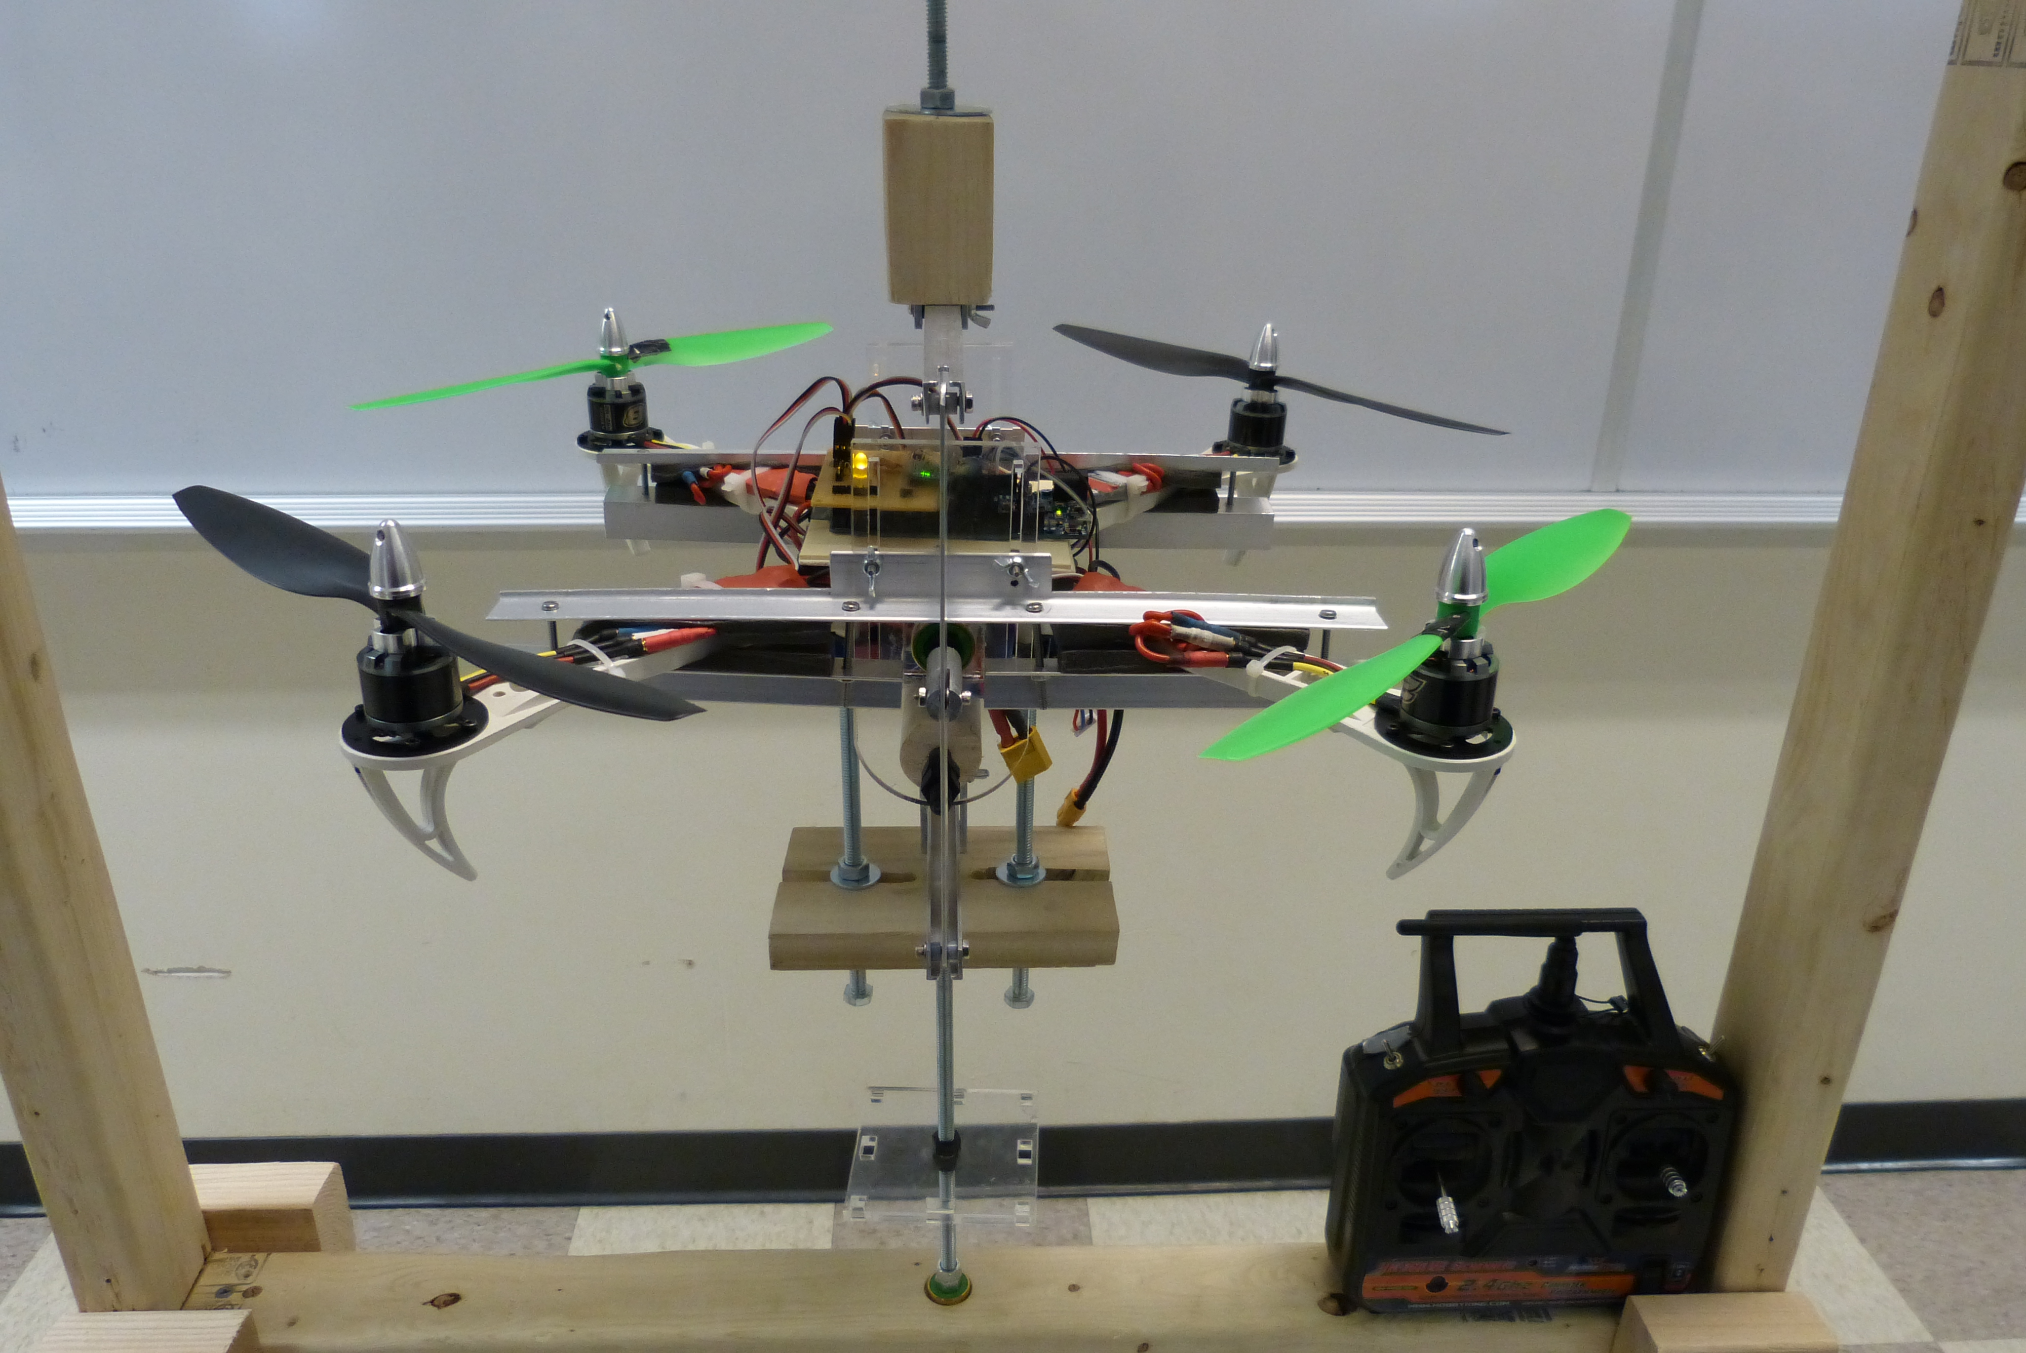

Figure 12. Test cage side view

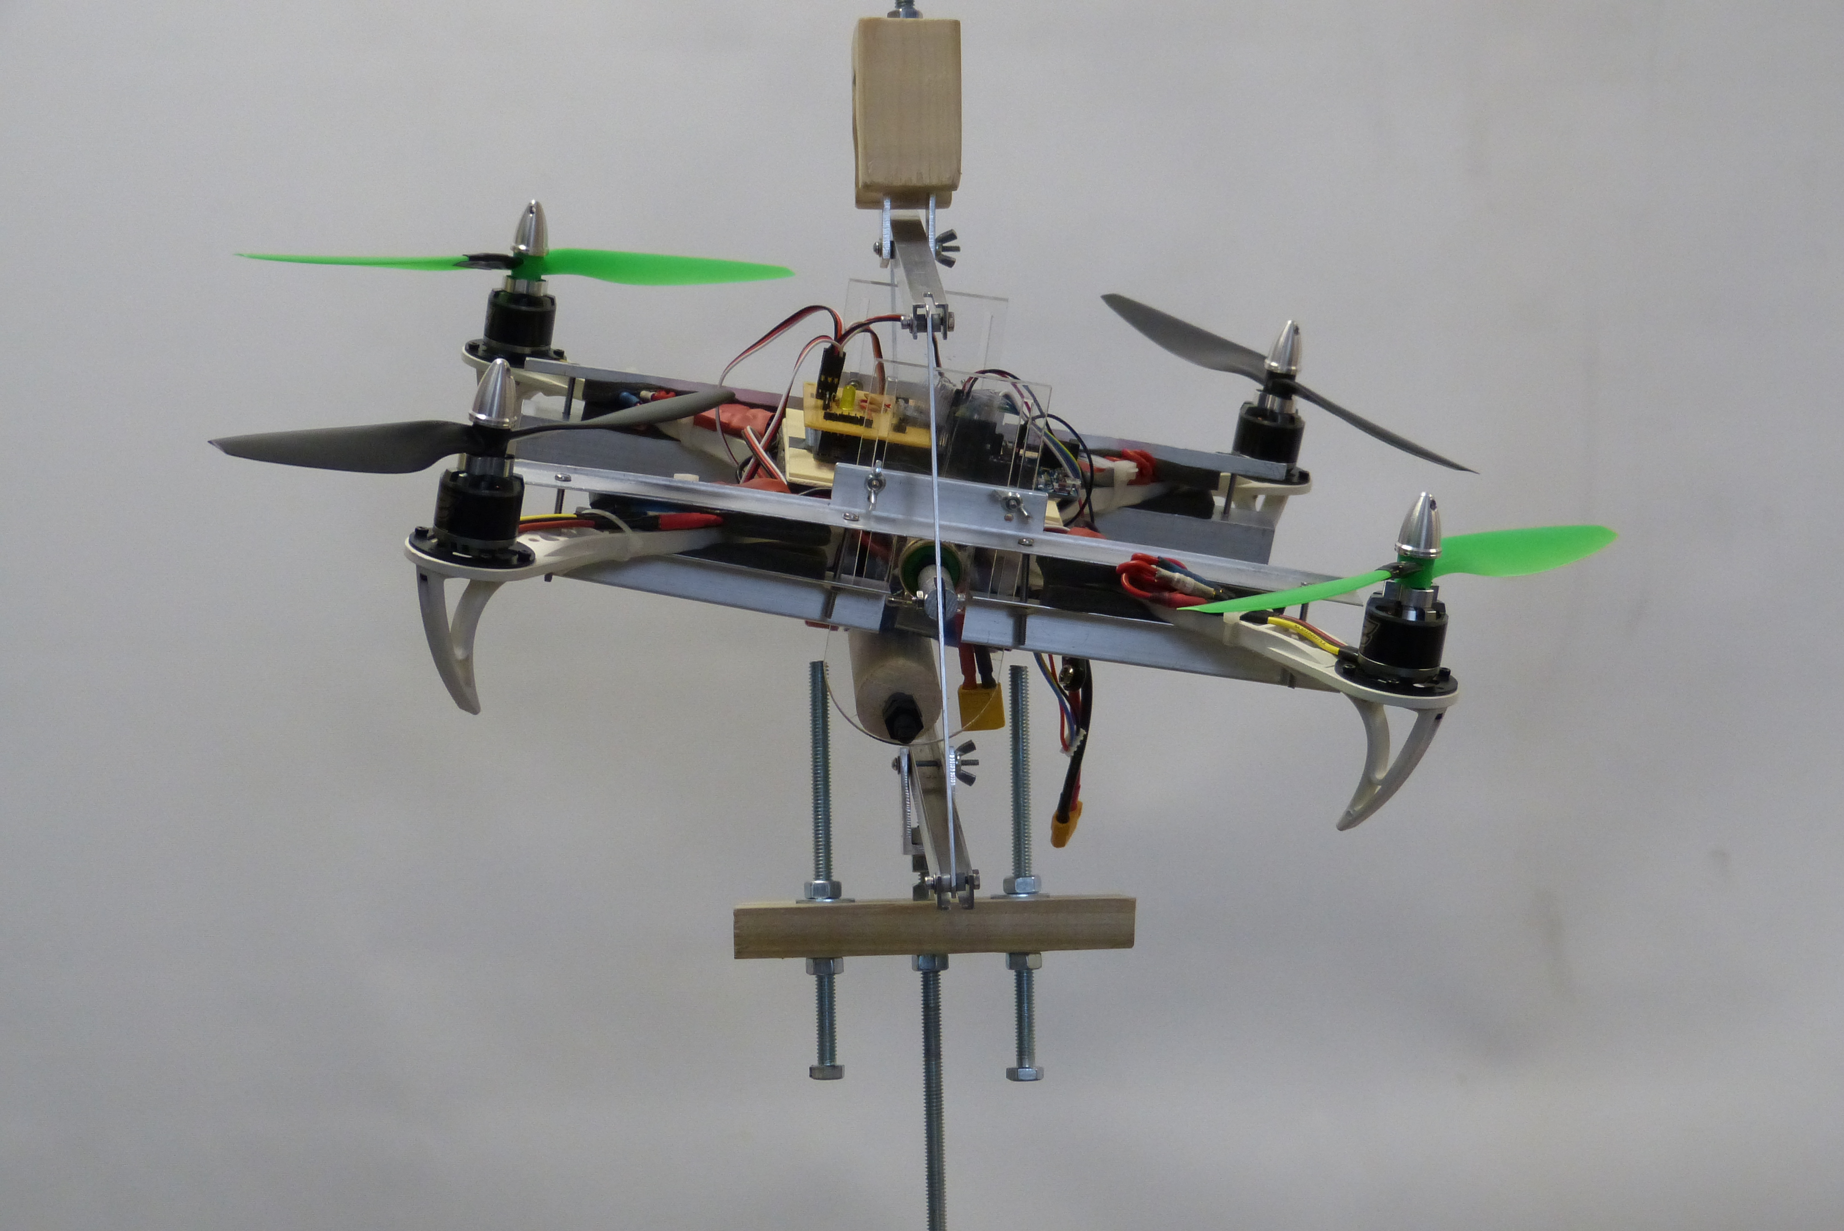

Figure 13. Test cage side view

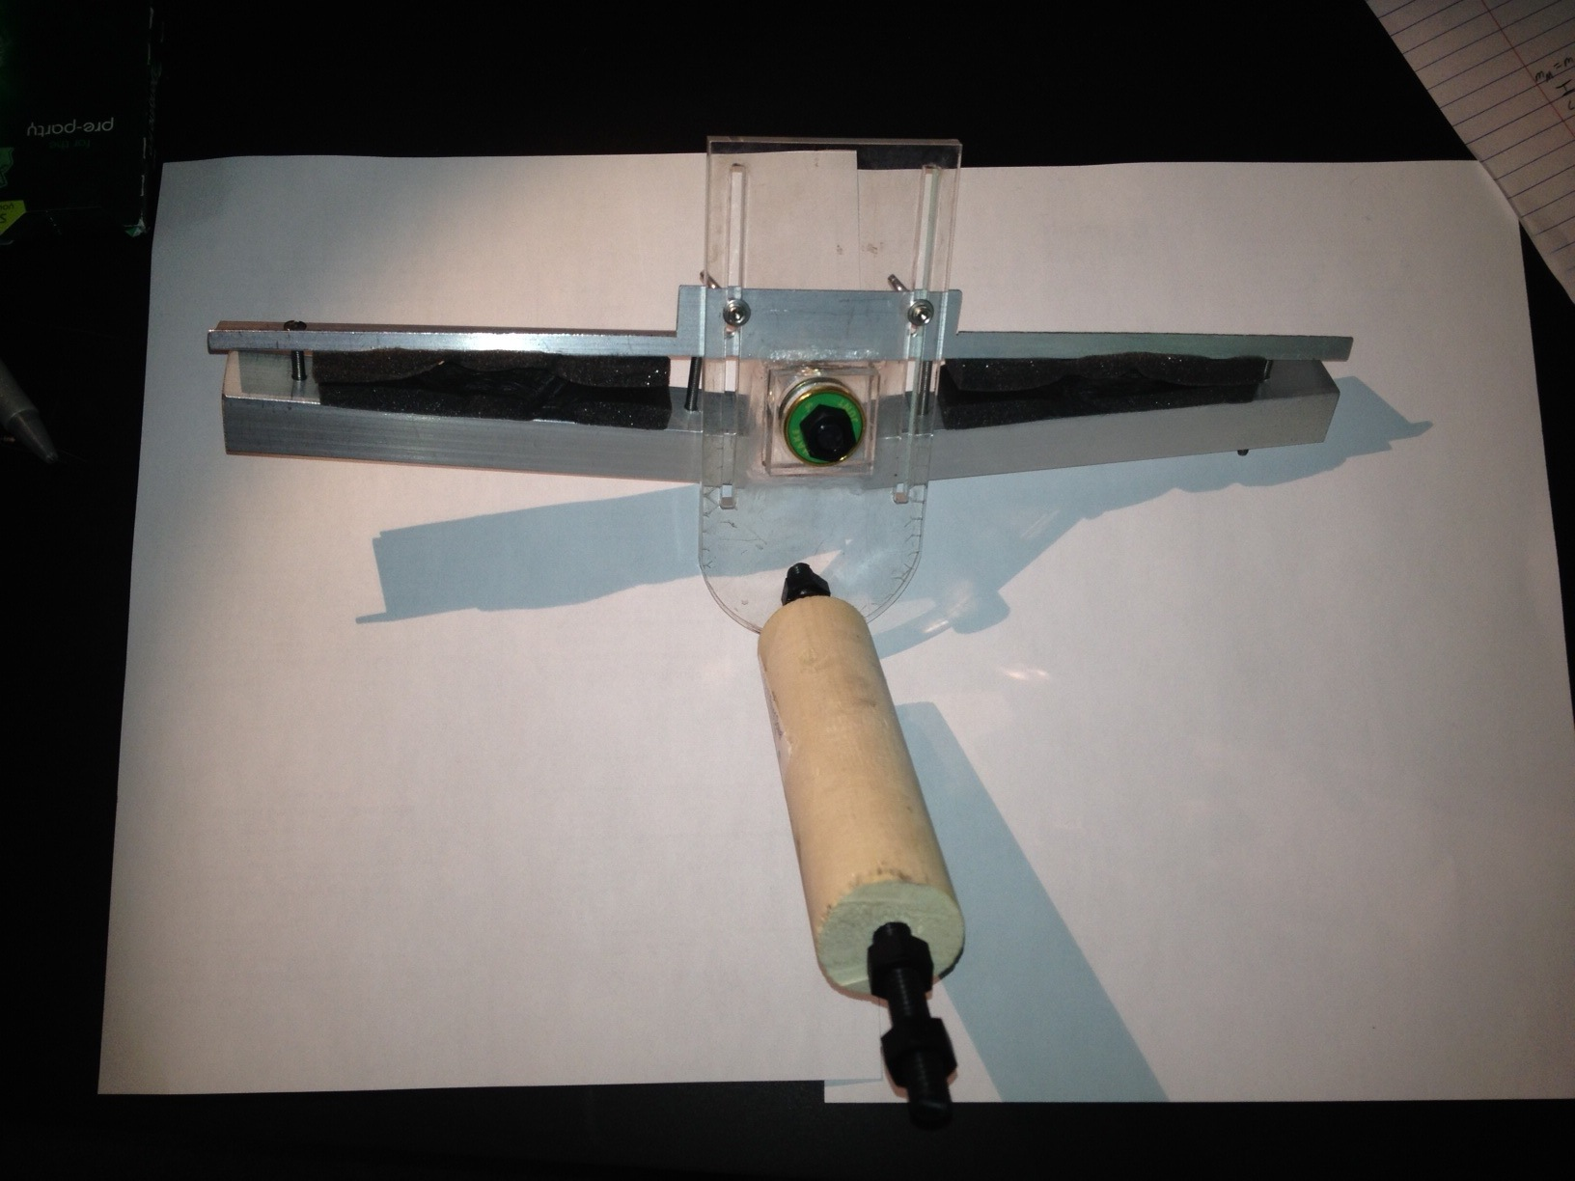

Figure 14. Half of the quadcopter mounting clamp assembly, with the lower support rod with attitude restraint dowel shown

## References

[1] P.E. Pounds, "Design, Construction and Control of a Large Quadrotor Micro Air Vehicle," The Australian National University, Sept. 2007

[2] Rick. "Designing a Thrust Test Bench." Web log post. Confessions of a Quadcopter Addict. Blogspot, 04 Apr. 2013. Web. 1 Dec. 2013. <http://confessionsofaquadcopteraddict.blogspot.com/2013/04/designing-thrust-test- bench.html>.

## Appendix: Combination torque and thrust rig difficulties

When constructing the thrust and torque motor modeling test stands, it might appear to the reader that to cut down on equipment and simply data collection, the two testing stands could be combined into one stand. This would allow both sets of data to be generated simultaneously, however, the following diagrams and equations show that this could potentially produce problems.

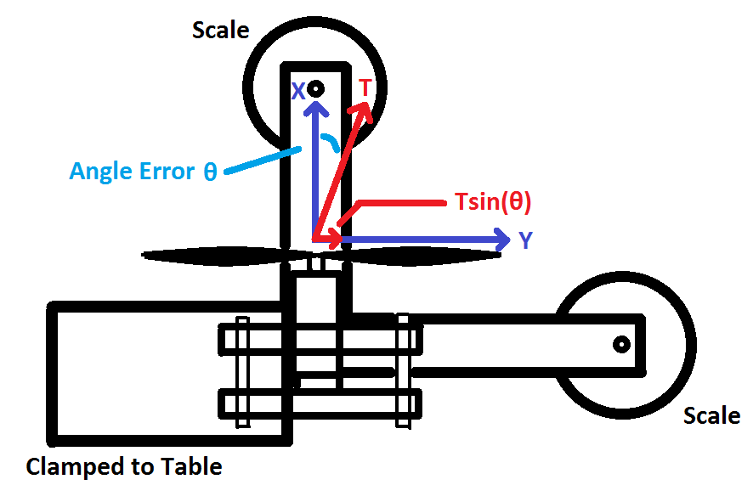

Figure 15. Top view of hypothetical combination test stand

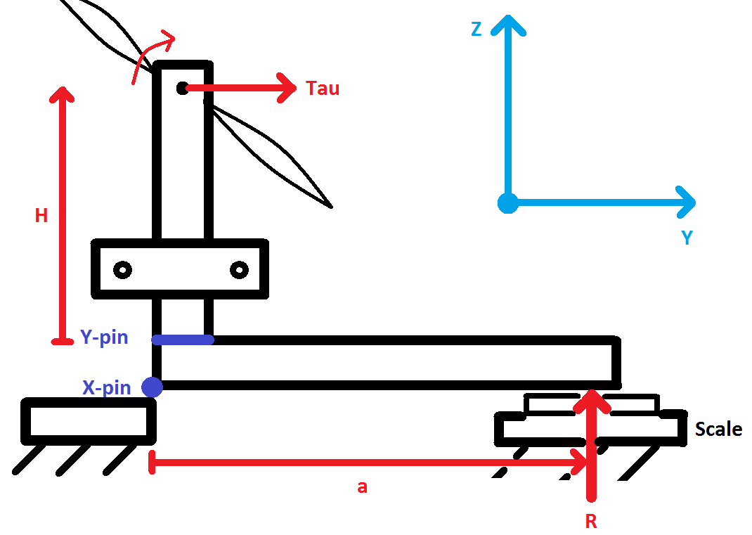

Figure 16. Side view of hypothetical combination test stand

**Ideal Situation:**

$$∑M_{x-pin}=0= -τ+R∙a$$

$$τ=R∙a$$

**Actual Situation:**

$$∑M_{x-pin}=0=- τ-Tsin\left(θ\right)∙h+R∙a$$

$$τ= -Tsin\left(θ\right)∙h+R∙a$$

As you can see from the diagrams and accompanying equations, in the ideal situation, the torque generated by the motor will be equal to the force read from the scale multiplied by the distance between the X-pin to the point of contact with the scale. Taking into account the possibility that the motor will not be aligned perfectly however, the thrust component will affect ihe torque measurement which can cause incorrect data to be recorded. This concern of thrust forces affecting torque measurements is alleviated if we reduce the $h$ term to zero (i.e. place the motor directly over the “x-pin”). This is the consideration that lead us to the design we’ve chosen. Of course, if a test rig is used that does not utilize the arm of the quadcopter, or in some way assures that θ is arbitrarily close to zero, a combination torque/thrust test system might be desirable. Since both of the testing systems we designed were small enough to be used on a tabletop, the need for a combination test system does not appear to outweigh the risk of errors.